ReserveMe

Hotel Reservation mobile application

Final Report

130322R

E.M.S.Lakmal

# Abstract/ Executive summary

Travelers of Sri Lanka spent considerable time of their journey for find accusations. Main objective of the “ReserveMe” is help them to reserve best accommodation quickly and easily. And help Sri Lankan hotel owners to promote their hotel and increases their business. There are two kind of users in “ReserveMe” as hotel owners and customers. Hotel owners can register their hotel in the system. Hotel customers can make reservation through the system.

Java was used as the programming language with Android Studio 1.4 as the IDE for the Android platform. Genymotion android virtual devices used for test the system. Data base was implemented in 000webhost free sever. Phpstome used as the IDE for write php files for access database. Image icon for the application are created using Adobe Illustrator CS6.

Contents

1. Abstract/ Executive summary 2

2. Introduction 4

2.1 Background of the application domain/ problem 4

2.2 Importance and main purpose of the system 4

2.3 Overview, summary of the system and used approach and outcome 4

3. Literature Review 5

4. System Models 6

4.1 System Requirement 6

4.2 System Design 7

4.2.1 Main architecture of the system 7

4.2.2 Class diagram of the system 8

4.2.3 Activity Diagram 9

*4.3* Database Design 11

5. System Implementation 12

5.1 Implementation Procedure 12

5.2 Materials 12

5.3 The Algorithm 12

5.4 Main Interfaces 13

*6.* System Testing and Analysis 15

6.1 Testing approach 15

6.1.1 Unit Testing, Results and analysis of testing 15

7. Conclusion and Future Work 16

7.1 Conclusion 16

7.2 Future Work 16

8. Reference 17

# Introduction

## Background of the application domain/ problem

Both local and foreign travelers face difficult situations when finding an accommodation in rural areas of Sri Lanka with required facilities and suitable amount. They spent considerable time of their journey for find accusations. Even they find accommodations in a normal way, there may be some negative facts like,

* Accommodation can be full.
* Not quality enough.
* Prices can be not good enough for the service.
* May difficult to reach that place

Also owners spend about 20% of their profit for third party intermediaries. Some hotels located far away from the town joiners even don’t know about such places.

So that hotels have less business.

## Importance and main purpose of the system

Using “ReserveMe” online android mobile application travelers can find accommodations just typing destination. Before make a reservation they can check ratings of each hotel, room availabilities and prices. Since they have lot of choices, can select the best accommodation considering above facts. Via this system they can avoid the problems and spend much time in their journey rather than finding accommodations.

Hotel owners can register their hotel in “ReserveMe” promote it and can manage their room charges, facilities and provide some special offers by looking at bookings. Since this is a direct booking hotel cane save commission fee charged by third party intermediaries.

## Overview, summary of the system and used approach and outcome

“ReserveMe” is an online android mobile application for hotel reservation. There are many web and mobile applications available for hotel reservation. But they only provide room availability, capacity and prices details of a particular hotel. And they are not even well updated. Users can’t view the locations of rooms before make a booking. So, since this is an online booking even same family may have rooms of deferent floors. As a solution for this I hope to provide graphical user interface which provide rooms map of hotel. Via this user will get know which rooms are booked and which are available. User can select rooms as his preference.

# Literature Review

There are many web and mobile applications available for hotel reservation. But they only provide room availability, capacity and prices details of a particular hotel. And they are not even well updated. Users can’t view the locations of rooms before make a booking. So, since this is an online booking even same family may have rooms of deferent floors. As a solution for this I hope to provide graphical user interface which provide rooms map of hotel. Via this user will get know which rooms are booked and which are available. User can select rooms as his preference. And also via goggle map people can search hotels and read their details but they cannot make reservation via it. And also it shows only famous hotel and hotel in urban areas only. But main targeted users of “ReserveMe” are hotels in rural areas of Sri Lanka like Kataragama, Anuradapura, Polinnaruwa etc.

# System Models

## System Requirement

Main functional requirements of “ReserveMe” are describe their. To ensure that the security of the system and for take initial details of each user each user system should allow to users to create a new user account. Before make a reservation customer should able to view details about the hotels. After make a reservation customer should able to rate the service of the hotel they take service. When make a reservation system should recode all the details about the booking and after customer confirm a booking, system should automatically marks relevant rooms as reserved. After customer leave the hotel system should automatically marks relevant rooms as available. Hotel owners should able to upload photos of their hotel, display some special offers and mark manual reservation.

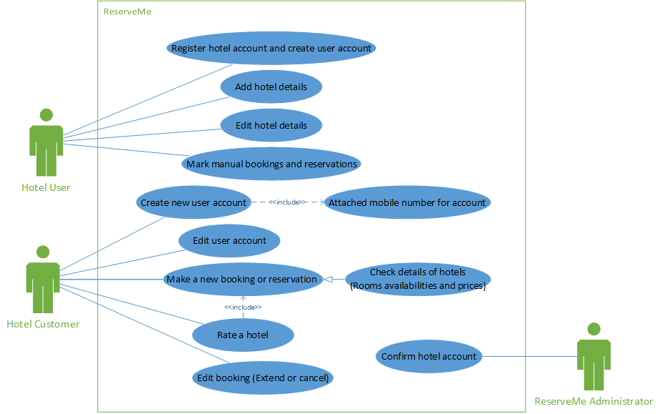Usability, supportability, Reliability, performance and security are the major non-functional requirements. With the lack of technological knowledge of hotel owners in rural areas they may require a training for get use to this system. “ReserveMe” should support for devices with less performances. System should able to repair with less time. User logging system will ensure the security and privacy of the system “ReserveMe”. Since there are no complex calculation inside processes, system might get much more time for one transition.

Figure 1use case diagram

## System Design

### Main architecture of the system

Main architecture sued is three layered architecture.

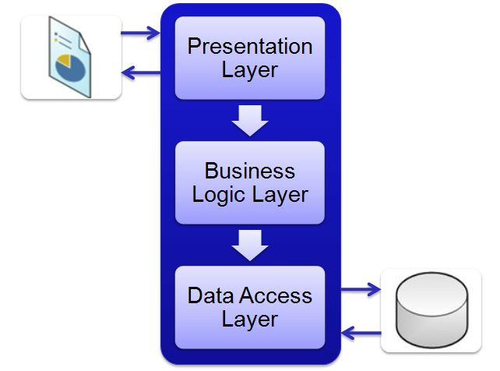

Figure 2 Main architecture of the system

* Sign and Sign Up UI
* View hotels and Make reservation UI
* Rating view
* Add and edit rooms view
* Hotel map view

Presentation Layer

* Customer controller
* Hotel controller
* Reservation controller
* Map controller

Business Logic layer

Online database

Data Access Layer

Figure 3 three layered architecture

Presentation layer provides the functionality required by using the application by user. All the graphical interfaces are relate to that layer. The business logical layer is used to decouple the user from the data storage and thus achieving security and privacy of data. The data access layer provides the data related functionality and methods of retrieving the data from data storage.

### Class diagram of the system

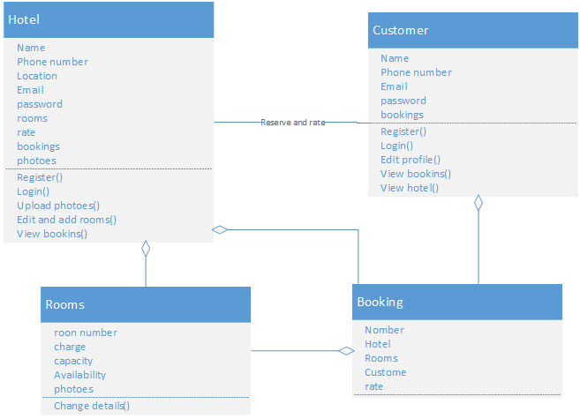Hotel, customer, rooms and booking are the class of the system. Hotel and customer associate with the customer reserve the hotel and rate the hotel. Each customer and hotel has booking and each Booking has rooms. Each hotel has rooms.

Figure 4 class diagram

### Activity Diagram

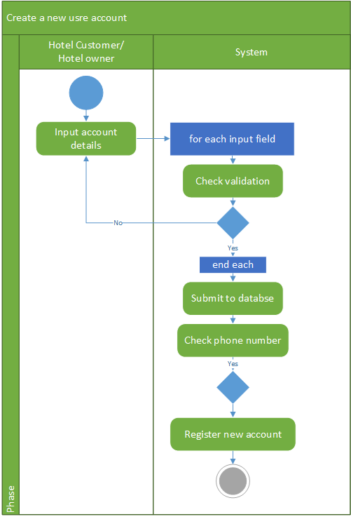

Figure 5 create new account activity

Register new account is one of main activity of “ReserveMe”. Activity flow of this is start with user fill input fields. Before submit data to submit data base system check the validations of fields. If all the fields are correct then system submit account details into server. Then if there is no existing account in database for that phone number create the new account.

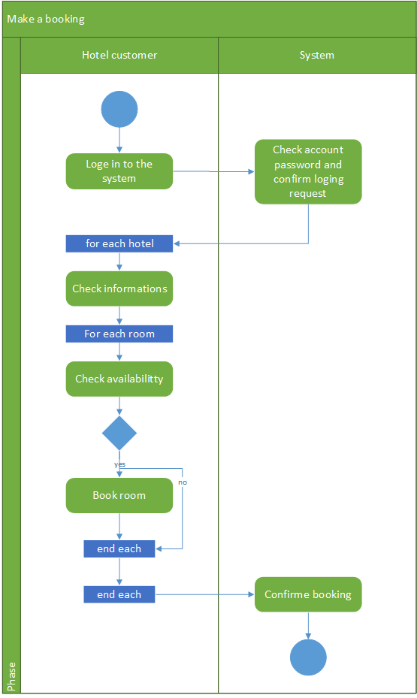

Figure 6 Reservation activity

In booking activity first customer need to login to the account. Then customer check availabilities and details of each room add rooms into booking list. Final all the details are completed system confirm the booking.

## C:\Users\sranga\Desktop\ER.pngDatabase Design

Figure 7ER diagram

Since the system nee a real time database. Database of the “ReserveMe” has created in the “000webhost” online sever There are five tables in the data base as hotel, customer, booking, room and booked room. In this system both kind of users can create account and log in to it. The “customer” and “hotel” tables are store details of registered user of the system. ‘Room’ table stores data about the each room of a hotel. One hotel may have many rooms so there is a one to many relation between hotel and room. There should be separate entry for each and every booking. The “booking” table keeps details about reservations. Customer can make many booking one booking has one hotel and more rooms. So there is a one to many relation between booking and hotel, booking and customer. And also relationship between “room” and “booking” is many to many, So database schema use another table called “booked room” represent that relation.

# System Implementation

## Implementation Procedure

Java was used as the programming language with Android Studio as the IDE for the Android platform. Android Virtual Device (AVD) was used to test every step of the system at first. And also used and android mobile phone with low performance with USB Debugging feature for test the system. When use the default AVD provided by the and Android Studio work at the same time it makes computer very slow as it takes most of the memory. So used Genymotion android virtual devices used for test the system. After using those devices that problem didn’t occur much.

Accessing of online database happened through the php files. Phpstome used as the IDE for write php files. 000webhost used as the online sever it provide phpMyAdmin free and open source tool to handle the administration of MySQL. Data base schema was implemented using that tool.

Image icon for the application are created using Adobe Illustrator CS6. Some demo photos for hotels and rooms are free downloaded from internet. Android need images with deferent resolutions for show in deferent size of displays. Final Android Resizer (Executable Jar File) for convert images from extra high density pixel to extra low density pixel.

Android SDK version 22 was used as the compiled version and the target SDK version with enabling system to work on devices which have Android version 14 or above. Android version 14 was selected as the minimum SDK as it is the major version of Android in the market. Almost all of the devices which are in use have this version or an above one. So all the android devices in use can use “ReserveMe” without any problem.

## Materials

Some demo photos for hotels and rooms are free downloaded from internet. Google map location details are user for locate hotels.

## The Algorithm

There are no large calculation in this system. So there are no complex algorithm used in “ReserveMe”. But some of small data handing algorithms written in the server side. For find nearest hotel location form database system used the below query.

"SELECT id, name , lat , lan ,loc_name, loc_address , email , SQRT(POW(69.1 * (lat - $start_lat), 2) +POW(69.1 * ($start_lng - lan) * COS(lat / 57.3), 2)) AS distance FROM hotel HAVING distance < 25 ORDER BY distance";

## Main Interfaces

Interphase are design using XML. Most of time used flow layout for design them. Otherwise orientation of component may change with the device size. Image icon for the application are created using Adobe Illustrator CS6. Android need images with deferent resolutions for show in deferent size of displays. So add different size of images from same image. Login view, Loading view, View hotel profile, hotel main view, customer main view, search hotel and reserve hotel are the main interfaces of “ReserveMe”.

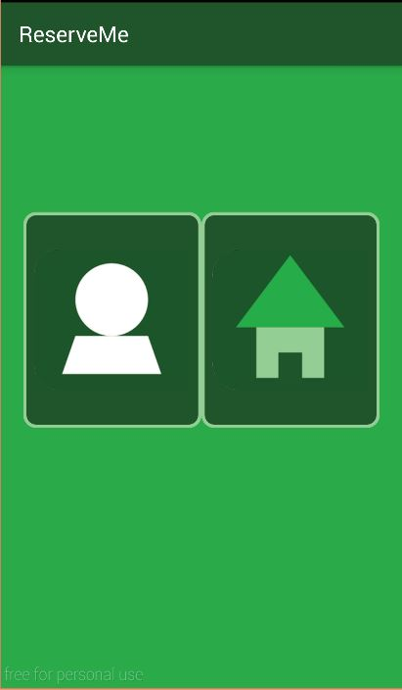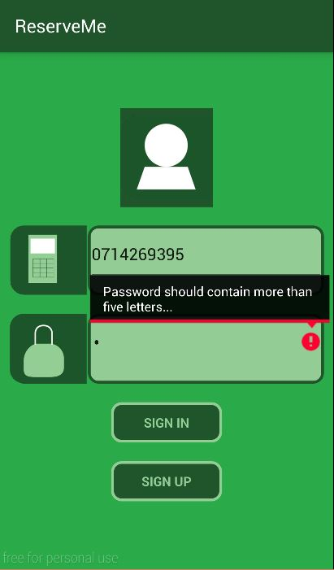

Figure 8 loading view

Figure 9 login view

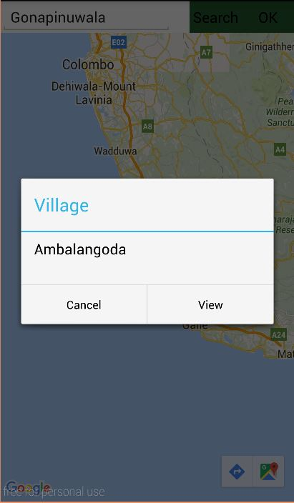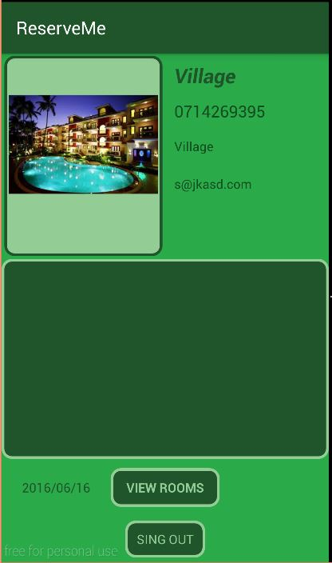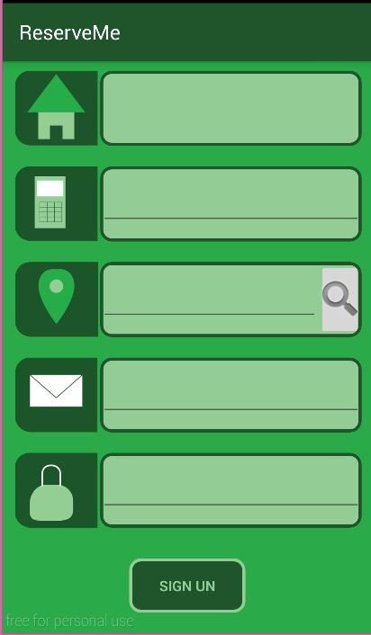

Figure 10 search hotel

Figure 11 hotel main view

Figure 12 log up view

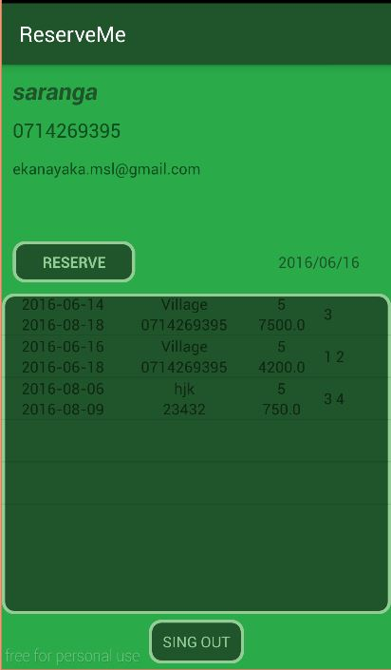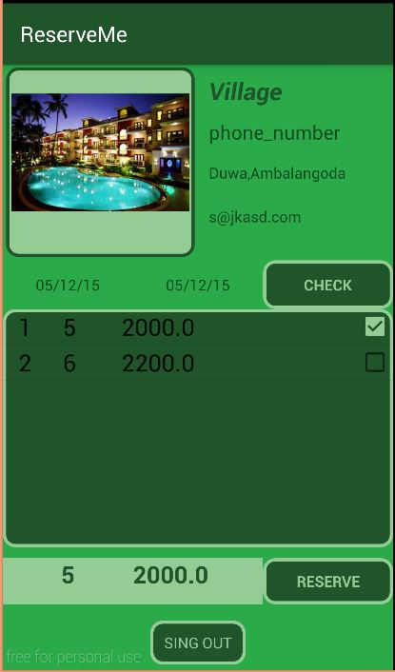

Figure 13 customer main view

Figure 14 reservation view

# System Testing and Analysis

## Testing approach

Testing of the ReserveMe is carried out under several categories. They are, Data and Database Integrity Testing, Function Testing, User Interface Testing, Performance Profiling, Load Testing, Security and Access Control Testing, Failover and Recovery Testing, Configuration Testing Those categories would comprise both manual and automated testing appropriately.

Unit test – junit:4.12, Android studio 1.4 debug monitor, Genymotion virtual devices, uiautomator and Android mobile devices was the tools used for testing.

### Unit Testing, Results and analysis of testing

Unit testing can be done in the implementation process while developing the code and it was used to test functionalities module or class individually at completion of unit by the developer. The primary goal of unit testing is that taking the smallest piece of testable software in the application, isolating it from the rest of the code and determining whether that piece of code performs as expected.

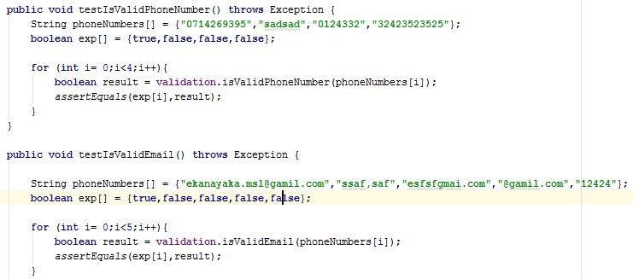C:\Users\sranga\Desktop\result.JPGJunit test cases for validation class are given bellow.

Figure 15 test case

Figure 16 results of unit testing

Result of the unit testing is given below

# Conclusion and Future Work

## Conclusion

The system developed successfully such that all the main functional requirements were achieved.

I hope after launching this in Google Play App store “ReserveMe” may not be famous among travelers because fist system need some considerable amount of registered hotels for reservation so fist I hope to promote this through hotel. It may be a difficult task sine lack of technology knowledge of hotel owners. They may require some training for use this application.

## Future Work

Currently users only can rate the hotels it is not sufficient. So I hope to introduce use feedback system for “ReserveMe”. Initially system data base is empty one so it may take some considerable time to fill. So I hope to extract some details like user comments, images of hotels shows in Google map.

# Reference

Three layered architecture image

[1] [*http://www.codeproject.com/KB/cs/Three_Layer_Architecture/3lyrs2.jpg*](http://www.codeproject.com/KB/cs/Three_Layer_Architecture/3lyrs2.jpg)

Figure 1use case diagram 6

Figure 2 Main architecture of the system 7

Figure 3 three layered architecture 7

Figure 4 class diagram 8

Figure 5 create new account activity 9

Figure 6 Reservation activity 10

Figure 7ER diagram 11

Figure 8 loading view 13

Figure 9 login view 13

Figure 10 search hotel 14

Figure 11 hotel main view 14

Figure 12 log up view 14

Figure 13 customer main view 14

Figure 14 reservation view 14

Figure 15 test case 15

Figure 16 results of unit testing 15